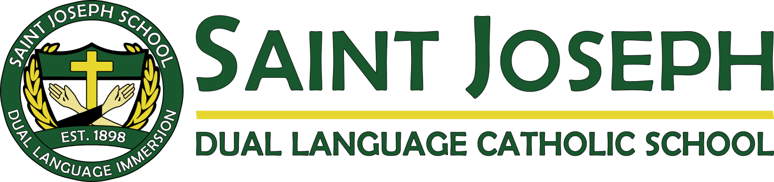
ST. JOSEPH SCHOOL 2021-2022 PROJECTED CALENDAR Dates and Times are subject to change – ALWAYS Consult Monthly Calendar
Classes are Monday-Thursday 8am-3 pm & Friday 8am-12:30pm

August
25th School Begins
28th Parent Bar-B-Q Tailgate

September
6th Labor Day NO School
19th Family Mass @11
23rd Back to School Night at 7pm

October
4th Blessing of the Animals @2:30
8th Faculty Retreat. NO School
11th Columbus Day/Indigenous People- NO School
17th Family Mass @11
19th Open House @7-9
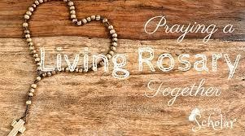

November 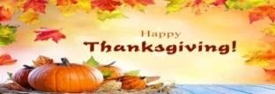
1st All Saints Parade @8am
5th End of 1st Trimester
12th Veteran’s Day- NO School
14th Family Mass
19⁻ 23rd Parent/Teacher Conferences
22-26 Thanksgiving Break
29th School Resumes
December 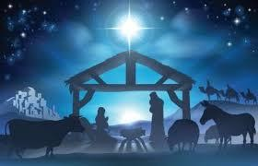
12th Family Mass
12-19th Book Fair and Holiday Gifts
19th Breakfast with Santa
20⁻ 31st Christmas Vacation

January
3rd School Resumes
17th MLK, NO School
30th Family Mass, Open House 11am-2pm
30-2/5 Catholic Schools Week
February
8th 100th day Celebration
18th Faculty DLI Training- NO School
21st President’s Day- NO School
March
2nd Ash Wednesday
3rd End of second trimester
April
10th Family Mass
14th 12:30 Dismissal
15-22nd Easter Vacation Begins
25th School Resumes

May
1st Family Mass
13th DLI Training- NO School
28th First Communion (2nd Graders)
30th Memorial Day, NO School
June
8th End of Third Trimester
11th Open House 9-11am
12th Family Mass 11am
13th Culmination Mass and Luncheon for 5th graders at 10-12
16th Minimum Day 12:30 Dismissal
17th Last Day of School 10:30 Dismissal

