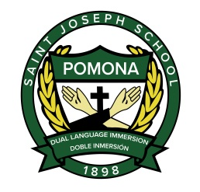
ST. JOSEPH SCHOOL 2019-2020 PROJECTED CALENDAR Dates and Times are subject to change – ALWAYS Consult Monthly Calendar

August
21st School Begins
31st Parent Tailgate

September
2nd Labor Day No School
8th Family Mass
11th Back to School Night at 7pm
27th No school

October
6th Blessing of the Animals @8am
20th Family Mass
28th Living Rosary @11
31st All Saints Parade- Min Day
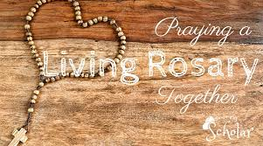

November
1st Harvest Festival
8th No School, Staff Training
11th Veteran’s Day, No school
14th Awards Assembly @11, Parent conferences begin
15th Parent Conferences- No School
17th Family Mass
25th Thanksgiving Break Begins
December 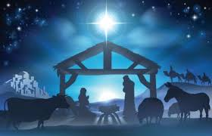
2nd School Resumes
9th Immaculate Conception Mass
15th Family Mass, Breakfast With Santa
23rd Christmas Vacation Begins

January
6th School Resumes
20th MLK, No School
24th Progress Reports
26th Family Mass, Open House
27-31st Catholic Schools Week
February
7th 100th day Celebration
12th Minimum Day
16th Family Mass
17th President’s Day, No School
26th Ash Wednesday

March
2nd No School
6th End of 2nd Trimester, Awards @11
16th Family Mass
April
8th Easter Vacation Begins
20th School Resumes
26th Family Mass
28th Progress Reports

May
15th No School
17th Family Mass
25th Memorial Day, No School
June
14th Family Mass
16th 5th Grade Culmination (5th grade last day)
17th Awards Assembly
18th Kinder Promotion-Minimum Day for all students
19th Last day of School- Minimum Day

